APLS OWNERS’

For the use of the Ecological Lac des Sittelles owners

Version.8

www.lac-sittelles.org info@lac-sittelles.org

INDEX
Introduction 2
Together! 3
SECTION 1 – The APLS, your Association 4
SECTION 2 – Beaches and Ponds 6
SECTION 3 – Boats and motors 9
SECTION 4 – Walking trails 10
SECTION 5 – Tennis and Fishing Clubs 13
SECTION 6 – Other Services 14
SECTION 7 – Summer Activities 15
SECTION 8 – Being a Volunteer 16
SECTION 9 – Public Services 18
SECTION 10 – Domestic Animals 21
SECTION 11 – Good Neighborhood 22
SECTION 12 – Roads 23
SECTION 13 – Home or cottage rentals 24
SECTION 14 – Environment 25
SECTION 15 – Wild animals 31
SECTION 16 – Useful Numbers and Addresses 33

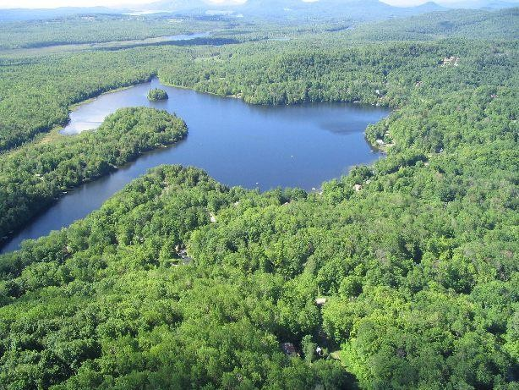

Destined for the owners of homes and lots on the Lac des Sittelles Ecological Domain, this Owners’ Guide contains all the information related to the services, best practices and regulations to enhance:

- neighbourhood harmony amongst residents and their guests and renters;
- everyone’s health and safety;
- the preservation of the quality of our environment;
- maintaining property values.

TOGETHER!
The APLS mission is to contribute to and promote the cultural, economic and social interests for its members whilst protecting the natural environment. Management of its assets, maintaining its facilities and common assets (beaches, trails, ponds, parks, etc.) are assured by the Board of Directors and a team of committed volunteers.

The slogan - Together - brings forth the union between residents based on volunteerism and a community spirit to enhance a harmonious cohabitation within the Ecological Lac des Sittelles Domain.

Please note that the APLS does not possess the power to enforce municipal, provincial or federal regulations. To do so, one must contact the proper authorities (refer to useful numbers and addresses at page 33). We basically count on everyone’s good will to live together in harmony.

Thank you for your cooperation!

SECTION 1 – The APLS, your Association

The Lac des Sittelles Owners’ Association, founded in 1974, is a non-profit association representing close to 700 owners of homes and lots. Its purpose is to organize common living and to represent all of the owners residing in the Domain in order to improve each member’s quality of life whilst respecting the environment and, in priority, the lake’s health.

The APLS advocates the involvement of as many people as possible in its management and leisure activities, and the sharing of the costs involved in the equitable use of the facilities, resources and collective assets. The strength and effectiveness of the Association’s representation with municipal and governmental bodies rests on the group spirit of its members.

BEING A MEMBER OF THE ASSOCIATION
One can be a member of the Association on two conditions:
- possess property or land on the territory of the Ecological Lac des Sittelles Domain;
- having paid one’s membership dues.
The annual fee is payable by all owners of the domain. The income generated by membership dues is used to manage and carry out various projects to preserve the lake and provide services to the community. Payment of the annual membership fee is compulsory. Indeed, all the owners have the notarized obligation to participate in the common costs in exchange for a membership card which gives access to the common facilities and services.
An invoice to pay your dues is usually sent in January each year. The amount is set annually by the Board of Directors.

For an additional fee, you can also join the Sittelles Tennis Club and the Sittelles Fishing Club and, depending on availability, reserve one or two places on the boat racks at the beaches. To find out more, visit www.lac-sittelles.org

THE BOARD OF DIRECTORS
The APLS is managed by a Board of Directors made up of eleven members. Each of them holds a function : presidency, vice-presidency, assistant treasury, secretariat. In addition, six directors each have responsibilities: roads and trails, communication, environment, boats, trade work and beaches and community life. The members of the Board work on a voluntary basis and are elected at an annual general meeting, for a two-year term, and in alternation for approximately half of the members.

To consult the list of members of the APLS Board of Directors, refer to www.lac-sittelles.org

The General Assembly usually takes place in April of each year. Board members prioritize and manage projects and related expenses based on decisions taken at the General Assembly, all in the interest of the owners of the Domaine Écologique du lac des Sittelles.

SECTION 2 – Beaches and Ponds

BEACH 1 – COLIBRIS – 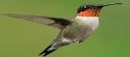
BEACH 2 – HUARDS – 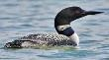
BEACH 3 - MÉSANGES – 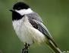
BEACH 4 – TOURTERELLES – 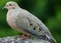
GRAND-DUC POND –

LAKE ACCESS
The lake is private and its access is strictly reserved for the owners of the Ecological Domain of Lac des Sittelles and their guests. No watercraft with a gasoline engine is authorized on the water bodies of the Estate (see section 3, Watercraft and motors).

BEACH ACCESS
The four beaches are private. Only owners of a property or lot at the Domaine who are members in good standing, their guests or their tenants, have access to the beaches. For security reasons, the beaches are closed from 11 p.m.

A person monitors access to the beaches and may ask you to present your membership card and identify yourself. We ask that you treat this person with respect.

SAFETY AND CIVILITY ON THE BEACHES
INSTRUCTIONS IN FORCE ON THE BEACHES OF THE DOMAIN.

- HAVE THE MEMBERSHIP CARD ON HAND AND PRESENT IT UPON REQUEST
- FISHING ON ALL DOCKS AND PLATFORMS IS PROHIBITED
- GLASS CONTAINERS ARE PROHIBITED
- BARBECUES ARE FORBIDDEN
- ONLY ONE PICNIC TABLE PER GROUP
- CLEAR THE TABLE WHEN YOU HAVE FINISHED EATING
- LIMIT THE NUMBER OF GUESTS AND THE TIME OF ATTENDANCE DURING THE PERIODS OF HIGH TRAFFIC
- REGISTER FOR THE USE OF SELF-SERVICE PEDABOATS (www.lac-sittelles.org)
- PROHIBITION OF PONTOONS AND MOBILE DOCKS FROM MOORING OR RIDING NEAR THE BEACHES
- NO GARDEN CHAIRS ON THE DOCKS

SAFETY TIPS

- SUPERVISE CHILDREN AT ALL TIMES
- SAFETY VESTS RECOMMENDED
- RESPECT YOUR PHYSICAL AND TECHNICAL CAPABILITIES BEFORE UNDERTAKING A NAUTICAL ACTIVITY

Grand-Duc Pond
In addition to the beaches, this other body of water, located near 14 rue des Plaines, is accessible to owners who are members of the Association. Swimming is permitted there and it is also the only place where dogs are allowed to swim.

BOAT RACK SUPPORTS
The boat racks at the four beaches are reserved for members in good standing. These locations are priced and the fees are added to your membership fee. For more details, read the next section.

The APLS cannot be held responsible in the event of theft or damage to boats stored on the beaches.

DOGS AT THE BEACH
It is allowed to bring dogs to the beaches, but they must remain on a leash and swimming is prohibited. Swimming for dogs is permitted at the Grand-Duc Pond only.

LAWN MOWING AND WEEDING
Lawn mowing and maintenance of chemical toilets at beaches and playgrounds are contracted out. In order to preserve the lakeshore and prevent erosion, it is forbidden to weed or plant shrubs or plants without first consulting the APLS

BEACH CLEANLINESS
Each beach has a garbage can, a bin for recyclables and a chemical toilet. This equipment is made available to beach users only. Everyone's cooperation is requested to ensure the cleanliness of the premises. Geese fences are installed at each of the beaches to prevent them from accessing the land and soiling it with their droppings. Each member is responsible for replacing these fences after their visit, or if they find that they have been left open.

THE ISLAND
A small wooded island is located on Lac des Sittelles near beach 4. This island is private and access is prohibited. It is an ecological conservation area, in particular for the reproduction of loons.

SECTION 3 – Boats and motors

Boat racks for kayaks, canoes, paddle boards, etc., and dock locations for rowboats and pedal boats are provided at the four beaches and are reserved only for members in good standing of the APLS. These sites are priced and their cost, established according to the type and number of boats, is added to the basic contribution. When you have a space, a sticker to be affixed to your boat is given to you to confirm your place. Depending on availability, each owner can obtain a maximum of two spaces for their boats.

No sticker is required for owners who store their boats on their property.

Unless otherwise indicated, users can place their boats on the sites starting May 1st. The deadline for removing boats on racks and wooden docks is October 31. For boats on aluminum dock’s structure, the deadline is October 1. Boats that are not removed from sites on these dates will be moved by the APLS at the expense and risk of their owners, who could lose their sites the following year.

Since 2021, the owners of the Domaine can take advantage of a self-service pedal boat at each of the beaches. Self-service pedal boats are installed at the docks and identified as such. To use them, you must register and agree to comply with the safety rules.

We ask you to respect the safety rules and take care of the pedal boat as if it were your own.

Electric Motors

Petrol engines are prohibited on Lac des Sittelles. The APLS allows low-power electric motors that do not produce waves. Registration is free of charge. All electric motors must be registered by completing the Electric Motor Registration Form. You will receive a sticker to affix to your engine. At the annual renewal of your APLS membership, mention if you wish to register your electric motor and a new sticker will be sent to you.

For all details of the costs and rules, consult https://www.lac-sittelles.org/emplacements-et- embarcations

SECTION 4 – Walking trails

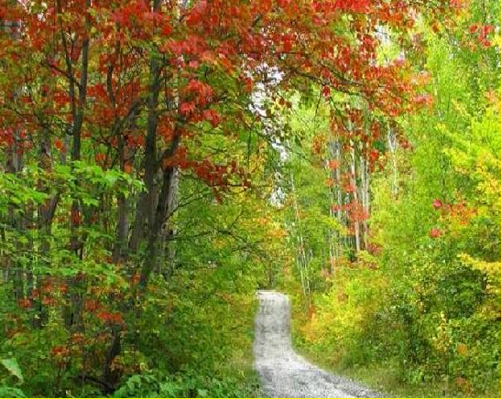

The Lac des Sittelles territory has five hiking trails accessible to members and their guests. Use them in the summer or in the winter as a snowshoe trail. Caution is advised as some sections can be steep and slippery. Trails are accessible to members and at your own risk. Dogs must be kept on a leash at all times.

The long path Sorel-Herzog¹
A 6 km trail, the first access point of which is at the postal shelter, at the entrance to the Estate. This trail crosses several peaceful roads and portions in the forest in the mountain to end at the other end of rue du Lac-des-Sittelles, near 188.

This great trail takes the streets of Lac-des-Sittelles, Hêtres, Framboisiers, a crossing (thanks to a private agreement), then rue des Frênes, the Pines trail, the rue des Ormes, the Junipers, rue des Pruches, rue des Merisiers, rue des Vignes and rue des Plaines, the path towards rue des Tilleuls, rue des Tilleuls and, finally, the path at the end of rue des Tilleuls towards rue du Lac-des-Sittelles.

Path des Hêtres
A 460 meters trail. The start is at the bottom of rue des Cormiers, at the corner of rue des Hêtres, and the path runs along the mountain for a nice round trip. Private land with a perpetual right of way granted to the APLS.

1 Sorel Herzog is the founder of Development Quatre-Saisons, which now bears the name of Ecological Domain of Lac des Sittelles.

Path des Châtaigniers
Course of 910 meters. The start is on rue des Merisiers, opposite the new playground and joins rue des Châtaigniers. Thereafter, the path continues at the end of rue des Châtaigniers to reach the end of rue des Merisiers.

Path des Quenouilles
Winter trail of 450 meters. The starting point, left on rue des Quenouilles at the entrance to the Estate. It leads to Lake des Sittelles.

Path de l’Impasse
Short path of 180 meters linking rue de l'Impasse des Ruisseaux to rue des Genevriers and
rue des Chenes.

Trail map
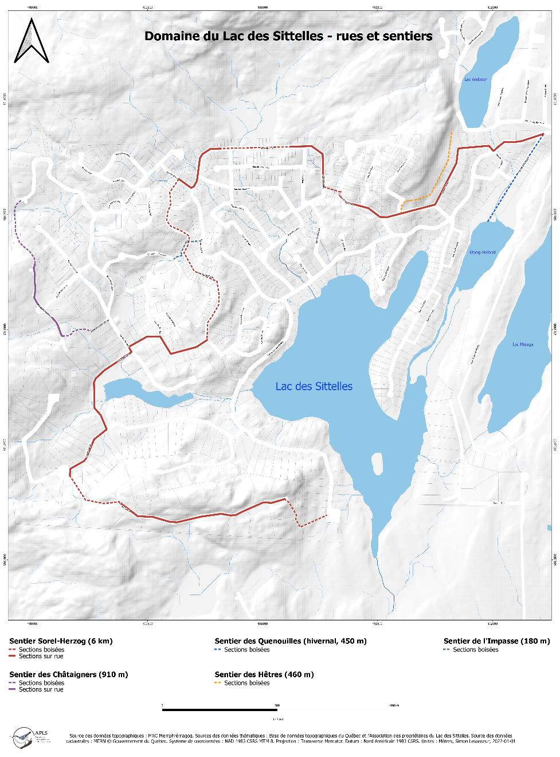

To preserve the environment and ensure your safety, the APLS recommends staying on the marked trail. Fallen trees or branches along the trails may be moved parallel to the trail by hikers.

The trails have all been marked
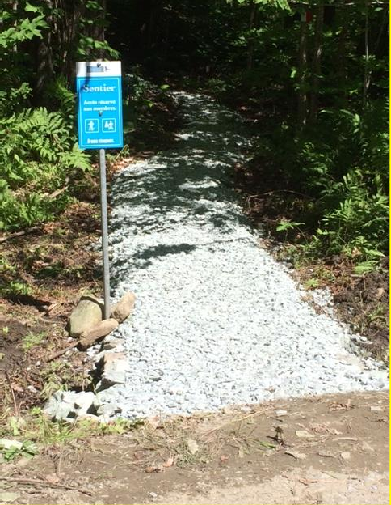

Playground: Etang des Merisiers Park
A new multifunctional park has been accessible since spring 2022. There is a small pond, two petanque courts, a volleyball court and a community garden. The park is located on rue des Merisiers.

SECTION 5 – Tennis and Fishing Clubs

You can join two clubs which are run independently.

Sittelles Tennis Club
Membership fees for the Tennis Club are $45 annually per property. Being a member allows you to play on a well-maintained double court, which was resurfaced in 2021. To find out more about the Tennis Club, see the tab on this subject in the APLS website, www. lac- sittelles.org

Fishing Club
Membership fees are $45 annually per property. Each year, the Club stocks 2,000 to 3,000 trout in the lake. To find out more about the Fishing Club, see the tab on this subject on the APLS website, www.lac-sittelles.org

To join the Sittelles Tennis Clubs or the Fishing Club, please write to
tresorier@lac-sittelles.org

Other group activities are available on the APLS website.

SECTION 6 – Other Services

POSTAL SHELTER
In addition to the Canada Post mailboxes, there are three bulletin boards at the postal shelter.
- The first is reserved for the APLS for the posting of various notices that concern members; it is installed above a box where you can slip correspondence intended for the APLS or suggestions.

- The second is owned by the Municipality of Austin and is used for posting official documents and notices.

- The third is used to display local suppliers, for lost or found objects and to publish classified ads.

ELECTRONIC BULLETIN BOARD (FACEBOOK PAGE)
An electronic bulletin board is now available for residents of the Domain. Created by François Dorval, who is the Manager, this Facebook page makes it possible to offer goods and services and to socialize virtually. More than 450 members have already joined. In Facebook, type Electronic billboard of the Ecological Lac des Sittelles Domain. Please note that this Facebook page is a personal initiative of our members and is independent of the APLS.

BOOKCASE
The Cultural Committee of the Municipality of Austin provides its citizens with bookcases installed in various sectors of its territory, including one at the postal shelter. You can borrow the books there: it's free. And you can also drop books there that you want to share with your fellow citizens.

APLS WEBSITE
To find out all about the APLS, its mission, its activities and more, visit www.lac-sittelles.org. A downloadable version of the Owner's Guide is also available there.

SECTION 7 – Summer Activities

NEIGHBOURHOOD PARTY
This festival usually takes place in June and allows you to get to know the other residents and vacationers of the Domain.

CORN ROAST

In August, the traditional APLS Corn Roast invites all owners to come and celebrate the end of summer.

You are all welcome!

SECTION 8 – Being a Volunteer

VOLUNTEERING
Volunteering is one of the foundations of the Association. It keeps the cost of the annual membership fee low in relation to the services offered. In addition to the members of the Board who act on a voluntary basis, a dynamic team of volunteers participate in the maintenance and repair of equipment installed at the beaches, trails, parks and ponds of the Domain, etc. Volunteers also perform office work or various other tasks requiring special expertise. This collective effort makes it possible to maintain the remarkable quality of life that distinguishes the Estate. Without volunteers, the APLS could not exist!
CALL FOR VOLUNTEERS!
The Association always needs new volunteers. The strength of numbers makes it possible not to always solicit the same people.

We therefore invite you to join our team of volunteers. Write to us at info@lac- sittelles.org specifying what kind of help you would be able to provide. Here are some examples of tasks that are carried out by our team of some 70 volunteers.

GRANDE CORVÉE
Coordinated by the Municipality of Austin each spring, the Grande Corvée allows volunteers to participate in the major cleaning of the paths, ditches and beaches of the Domain. This collective chore is always done in a good mood!

Other possible chores

Manual Work
  - Repairs and installation of docks and platforms
  - Repair of boat racks
  - Repairs and maintenance of parks and playgrounds
  - Weeding at beaches and common spaces
  - Planting at the beaches, ponds and other common spaces
  - Maintenance of trails
  - Production and installation of signs and panels
  - Painting
  - Installation and removal of aluminum docks
  - … and many other tasks!

Administrative tasks
  - General office work
  - Translation, editing and proofreading of texts
  - Visual conception (ex., the APLS logo)
  - IT support
  - Website management
  - Legal advice, audit and accounting expertise
  - And others!

Together, let's help improve our environment!

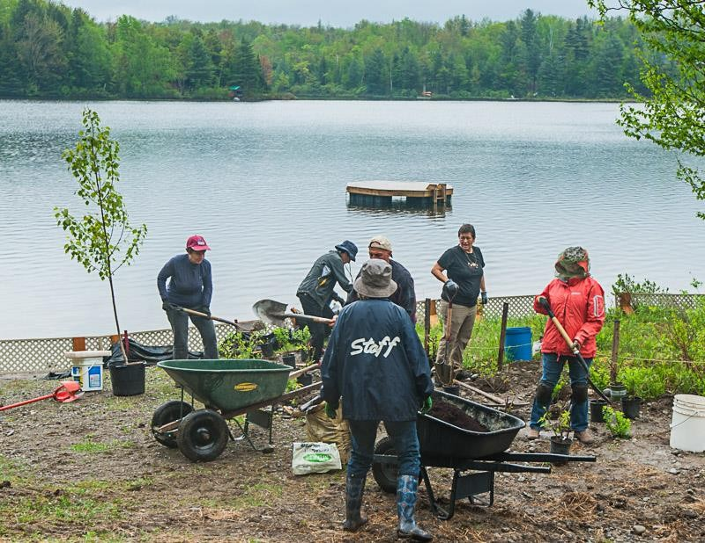

SECTION 9 – Public Services

For more information on municipal services and regulations, contact the Municipality of Austin
21, ch. Millington, Austin (Québec) J0B 1B0 819 843-2388
819 843-8211
info@municipalite.austin.qc.ca https://municipalite.austin.qc.ca/
City Hall: 819 843-2388
Fire permit: 819 843-0000
Road network: 819 820-5928

RESIDUAL MATERIALS
The collections of residual materials (green bin) and organic materials (compost/brown bin) take place on the dates specified on the calendar available on the website of the Municipality of Austin, https://municipalite.austin.qc.ca. As we live in a rural area, there is no collection of dead leaves in the fall. They can be scattered in the forest or placed in your brown bin. Note that no bag, container or other object placed outside the wheeled bins is picked up during these collections.

RECYCLABLE MATERIALS
Recyclable materials must be placed in a blue bin provided by the municipality. N. B. No bag
or other container is picked up by garbage collectors.
LARGE PIECES OF GARBAGE
As of April 1, 2015, the Municipality of Austin no longer offers bulk waste collection.
In addition, the municipality offers its citizens free access to the Magog Eco Center to help them reduce the volume of landfilled materials and promote the reuse and recycling of recoverable materials. To take advantage of access to the Magog Eco Center, you must obtain a card by presenting yourself in person at Austin City Hall. Note that certain materials and objects are priced when you bring them to the Eco Center. For more information, consult the information sheet on the Eco center, on the municipality's website.

COMPOSTING

The Municipality of Austin encourages the collection of organic plant and animal waste, including animal excrement. No plastic bags, whether recyclable or compostable, are allowed in your brown bin.

To learn more about residual materials, compost and what is or is not recyclable, consult the Guide “Bon débarras” available on the website of the Municipality of Austin.

OTHER RULES TO KNOW
In addition, here is an overview of the main regulations to know to promote a good neighborhood at the Domain.

OPEN SKY FIRES
Under paragraph 17.1 of By-law 09-370 on Fire Safety, it is strictly forbidden to light a fire in the open air without first obtaining a fire permit (open fire) from the Municipality’s Fire Department. This permit is free and can be obtained at any time by calling 819 843-0000.

FIREWORKS
Under Article 18 of the same by-law, the use of fireworks with limited risk is prohibited, except with the authorization from the Director of the Fire Department of the Municipality. To use fireworks, you must submit a written request at least 15 days before the scheduled date. Written authorization is delivered at least 48 hours before the event.

Fireworks are prohibited on the beaches in order to avoid pollution of the lake by pyrotechnic residues. This prohibition also applies to lakeshore owners.

GARAGE SALES
Up to three garage sales per home per year are permitted. You can obtain a permit free of charge by contacting the Municipal Planning Department at 819 843-2388, ext. 1.

MESSY PROPERTY
Pursuant to article 96 of By-law 01-264 concerning nuisances, it is prohibited to leave, on land whether built or not, any scrap metal, waste, rubbish of any kind, rubbish dumps, used tires, building materials or demolition, toxic products, used oils, combustible materials as well as dead animals. It is forbidden to leave there, a motor vehicle manufactured for more than seven years, not registered for the current year and which no longer works.

SCEPTIC TANK
Septic tanks are emptied every two years for permanent residents and every four years for seasonal residents. The municipality manages a verification program for septic systems dating back 35 years or more and residents must comply with the instructions issued. For more details, see the Frequently Asked Questions about the Municipality of Austin By-law 18-461.

TREE FELLING
A permit from the Municipality of Austin is required for the removal and major pruning of trees, except if they are diseased or present a danger. Find out before proceeding.

RENOVATIONS
A permit from the Municipality of Austin is REQUIRED to carry out renovations, expansion, work on the shore, installation of a swimming pool, addition of a shed, etc.

CAMPING
Camping is prohibited on the entire territory of Lac des Sittelles.

SECTION 10 – Domestic Animals

In Austin, it is the SPCA de l'Estrie that enforces municipal regulations regarding animals. You must therefore contact the SPCA to report a nuisance, a stray dog, a lost dog or cat, or an act of neglect or cruelty towards an animal. To do so, call 819-821-4727, or visit the organization's website at www.spaestrie.qc.ca.

PERMIT
By-law 20-480 concerning the control and responsible care of animals, adopted by the municipality in 2020, requires that cats and dogs wear a tag bearing their registration number; this includes microchipped animals.

DOGS ON LEASH
Dogs must be always kept on a leash, whether on the beach, in the streets or on the footpaths on the Domain’s territory. It is forbidden to let an animal loose outside the limits of the unit of occupation of the guardian in the absence of the latter. Outside these limits, the animal is considered a stray animal. An animal that escapes from its occupancy unit is presumed to have been released by the keeper.

CLEANLINESS
When walking your dog, bring a bag to pick up excrements. Civility is essential in the countryside as well as in the city. Avoid placing plastic bags in brown bins; your dog's poop bags go in the trash.

BARKING
Prevent your dog from barking unnecessarily. A muzzle may sometimes be necessary when you have guests who bring a dog that is untrained or unaccustomed to country life. The collaboration of all is requested to ensure tranquility in the Domain.

The breeding and trade of animals are prohibited on the territory of the Domain.

SECTION 11 – Good Neighbourhood

NOISE
Between 11 p.m. and 7 a.m., in places located less than 150 meters from an inhabited house, it is forbidden to carry out or have carried out work likely to make noise in such a way as to bother the neighborhood.

Avoid as much as possible, noises that can disturb the tranquility of neighborhood. Let's keep our environment serene and calm

At the beach, avoid imposing your music on others and use headphones. Respect
those who prefer to listen to nature.

LIGHT POLLUTION IMPACT
Going away for a few days or more? Think about the effects your lights have while you're away. Not only do they have a poor deterrent effect on thieves, as some studies tend to show that break-ins occur most of the time in broad daylight, but this unnecessary lighting disturbs your neighbours and stargazing. Instead, ask your neighbours to watch your property in your absence.

  - Adopt best practices to counter light pollution, namely:
  - Turn off your exterior lights at night;
  - Point the lights down to the ground, not up to the sky;
  - Install motion detectors or a programmable timer.

SECTION 12 – Roads

SPEED
The speed limit on the streets of the Estate is 40 km/h.
However, it is recommended to always reduce your speed near beaches and on all other streets to minimize the risk of accidents and dust. For the safety of pedestrians, keep to the right and slow down when you meet walkers.

STOP
A stop sign is installed at the exit of the Domain. Please respect it, as it is at the traffic junction with Webster Lake and the postal shelter. Also be careful at the intersection of rue du Lac- des-Sittelles and rue des Chênes: it is a crossroad where the risk of accidents is very real when cars and trucks meet at that point.

RECREATIONAL VEHICLES
The use of snowmobiles, ATVs (all-terrain vehicles) and motocross bikes is prohibited on
municipal streets and in the Plein soleil and Rocher boisé sectors.

SECTION 13 – Home or cottage rentals

Short-term rental (less than 30 days) is prohibited throughout the territory of the Domain. The Association closely monitors this activity. Offenders are promptly notified and risk being expelled from the Association and deprived of the benefits and services offered to members.

By virtue of the title deeds, no business can be established on the Estate.

Also consult the Municipality’s Zoning By-law No. 16-430 to learn more about the supervision of tourist residences. Such an activity is only permitted in certain sectors, but not at the Ecological Domain of Lac des Sittelles. If in doubt, contact us or the Municipality.

It is the responsibility of the owner to advise his tenant and his guests to respect good practices, laws and regulations in force in order to ensure a pleasant cohabitation for all.

A word of advice: if you are renting out your cabin or residence, put a printed copy of the
Owners’ available for the renters.

SECTION 14 – Environment

LAKESHORE
Under Zoning By-law 16-430, the shoreline must be 10 meters wide if the land is flat and 15 meters if the slope of the land is more than 30%. Any vegetation control intervention is prohibited (lawn mowing, brush clearing, tree felling, etc.), except in cases of absolute necessity and with the authorization of the Municipality.
Austin – 08-352
RECOMMENDED PLANTS
If you want to naturalize your strip of lakeshore, here is the list of some recommended plants, shrubs and trees.

Flowers
Blue flag iris – Cardinal's lobelia – Daylily – Rudbeckia – Canadian bloodroot.

Bushes
Holly – wild rose – bayberry – Canadian elderberry – serviceberry laevis.

Trees
Choke cherry – red maple – white willow – white cedar (cedar) – basswood.

RECOMMENDATIONS FOR THE PRESERVATION OF THE LAC DES SITTELLES

  - Ban the use of pesticides. Favour domestic compost to fertilize.
  - Always use phosphate-free detergents.
  - Do not throw ashes on the banks or in the ditches.
  - Do not uproot aquatic plants
  - Do not feed the geese.
  - Ensure the compliance and proper functioning of your septic system.
  - Clean any boat from elsewhere before using it on the lake.
Keep the lakeshore dense to prevent geese from settling there.

For more information, visit the RAPPEL website (Grouping of associations for the protection of the environment of lakes and watersheds), www.rappel.qc.ca and the APLS website, www.Lac- Sitelles.org.

DITCHES

According to the REMINDER, it is best to leave grass in ditches located on slopes. However,
one or two mowings per year can be done in the fall.

INVASIVE AND HARMFUL PLANTS: Vigilance on your property!

PHRAGMITE (COMMON REED)
Phragmites is an invasive plant, very damaging to the ecosystem and to biodiversity.
If you spot any on your property, it is important to cut it regularly in order to weaken it. Do not put the stems in the brown bin: throw them in the trash. If you see Phragmites growing on the lakeshore, try to control it, as Phragmites spread along the banks at high speed and kills everything in its path.
This plant is very present in our ditches and around the Grand-Duc Pond.

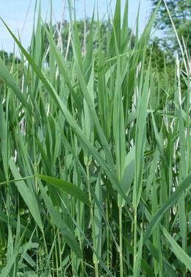
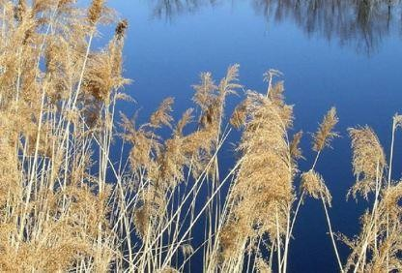
Phragmites stems Phragmites ears

JAPANESE KNOTWEED
With its hollow stems like bamboo and its very invasive roots, this plant, whose presence must be reported to the Municipality, can pierce asphalt and even concrete. If you have any on your property, it is very important to control it. It can be eradicated, at the cost of constant efforts that can extend over years. But in reality, it is practically impossible to eliminate.

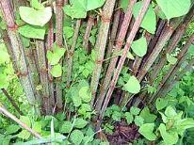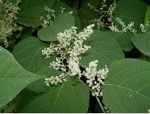

GIANT HOGWEED
Under Invasive Plant Species Regulation 17-448, this plant is reportable in Austin, which means that the municipality will work with you to eradicate it. Giant hogweed sap can cause second-degree burns to people and pets.

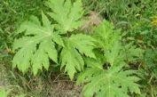
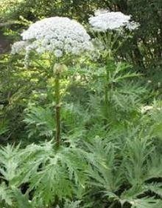
Juvenile plant Mature plant

If in doubt about identifying an invasive alien plant, contact us at environnement@lac- sittelles.org. The website of the Ministry of the Environment and the Fight against Climate Change also provides a lot of information on the issue.

Invasive and harmful species: Vigilance on our lake !

Status Report
Several lakes in the Eastern Townships are struggling with serious problems of invasive freshwater species. Fortunately, for the moment, the vigilance of the residents by washing the boats has preserved our lake from these harmful invaders.

A few species to look out for
ZEBRA MUSSELS

The zebra mussel is a small, invasive freshwater bivalve. It attaches to hard substrate (rocks, docks, aquatic plants, shells of other native molluscs.
The tiny zebra mussel reproduces at lightning speed. It displaces other native mussels and can prematurely age a body of water.
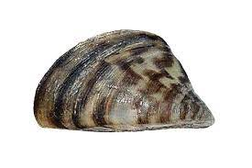

GEORGIAN VIVIPARIOUS AND CHINESE VIVIPARIOUS
They are very damaging freshwater snails for the ecosystem and for the biodiversity.

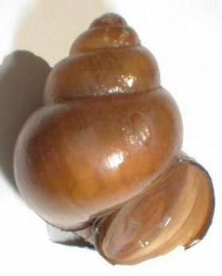

Steps to take to avoid contamination of the lake:

Nautical activities and recreational fishing
- Before leaving the body of water, empty all the water in your boat or your equipment (livewells, engine, bilge, coolers);
- When you get out of the water, inspect your boat, the trailer and the equipment used, completely remove the clumps or residues of aquatic plants, mud and organisms visible to the naked eye and dispose of them in a garbage can or place them far from the body of water;
- Wash more than 30 m from any lake or watercourse and properly dry the boat, trailer and any equipment that has been in contact with water. Preferably use hot water under high pressure to maximize washing efficiency.

SECTION 15 – Wild animals

It is forbidden to feed wild animals whether white-tailed deer, fox, skunk, raccoon, Canada goose or any other non-domestic animal.
GEESE
Geese that nest around the lake have become annoying birds on our shores. A major source of pollution, they jeopardize the health of our lake. It is therefore forbidden to feed these birds. Barriers have been installed at the beaches to prevent geese from settling there. Please put the barriers back in place after swimming.
At all times, but especially in spring, the nesting period, the cooperation of residents is requested to maximize efforts to control the presence of geese. We recommend that residents install barriers on their property and keep vegetation dense enough on the shoreline to prevent birds from nesting there.

BEAVERS
Herbivorous, the beaver likes to feed on aquatic plants, the fruits of terrestrial plants and deciduous trees (poplars, maples, alders and willows). Aspen is it’s favourite species.
The Wildlife Conservation Act prohibits the destruction of beaver dams. This practice is also useless, because the beaver will rebuild its dam each time. Trapping is also prohibited outside the trapping period – this is again a temporary solution, since other beavers will come to replace those who have been captured.
The best way to counter beaver damage is to protect trees with wire mesh about 90 to 120 cm high, because the beaver does not climb. It is useless to surround an entire place to protect it, because the beaver only enters by the edge of the water. Instead, plant species that it does not like, such as conifers.
The beaver represents an ally in the context of global warming, because it recreates an important biodiversity and allows the storage of a large quantity of fresh water. If infrastructures are not threatened, it is advisable to learn to live with the beaver.

WHITE TAILED DEER
Several residents of the estate deplore each year the loss of ornamental plants and shrubs that the deer loves. Let's not forget that on the territory of the Domain, the deer is as much at home as we are. The solution to keeping beautiful flowerbeds therefore consists in planting plants that he does not want. Some shrubs that resist it: bearberry, or bearberry (Arctostaphylos uvaursi), sweetberry (Comptonia peregrina), mountain laurel, also called sheep's crevard or sheep's laurel (Kalmia angustifolia), balsam bayberry (Myrica gale), potentilla (Potentilla fruticosa) and cranberry (Viburnum cassinoides). The deer does not

seem interested either in the wild rose or in the weigela, which blooms well and is very
resistant.

Loons
This migratory bird has disappeared from several lakes in the east of the continent due to pollution and acid rain. A precarious species, the loon is protected under the Migratory Birds Convention Act.
The loon needs peace and quiet, especially during its nesting period (mid-July) and the following two months, when rearing the young (one or two chicks), before they can begin their first migratory flight.
Disturbing loons can jeopardize the survival of the young. They may stop feeding, develop illnesses or be abandoned by their parents. We are lucky to have loons on the lake. They usually build their nest on the northern tip of the island.

To protect the loon, it is important to avoid approaching the island and its shores and to deliberately approach this bird to observe it.

POACHING
Poaching is present in our rural areas. If you hear gunshots outside the hunting season, in the evening or at night, it is important to report everything to the wildlife officers. To do so, call 1 800 463-2191 at any time. For more details, see the SOS Poaching website. You can also report online from this site.

SECTION 16 – Useful Numbers and Addresses

Emergency | 911
Info-Santé 811 | 811
Québec 511 (Transports Québec) | 511
Municipality of Austin | 819 843-2388
Open sky permits | www.municipalite.austin.qc.ca  819 843-0000
Memphremagog Police Department | 819 843-3334
Magog Hospital | 819 843-2572
Hydro-Québec – Outrages/ emergency | 1 800 790-2424
Hydro-Québec – Fallen trees (Pruning service) | 1 888 885-7252
Environnent emergency | 1 866 694-5454
Services Québec | 1 877 644-4545
Développement Quatre-Saisons | 819 822-7772  www.terrain-boise-estrie.com
APLS web site | www.lac-sittelles.org
APLS email | info@lac-sittelles.org

